**Software Requirements**

**Specification**

**for:**

**Amazon Clone**

## Version 1.0 approved

# Table of Contents

### Table of Contents Revision History

1. **Introduction**
   1. Purpose
   2. Intended Audience and Reading Suggestions
   3. Product Scope

### Overall Description

* 1. Product Perspective
  2. Product Functions
  3. User Classes and Characteristics
  4. Operating Environment
  5. Design and Implementation Constraints
  6. Assumptions and Dependencies

### External Interface Requirements

* 1. User Interfaces

### Analysis Models

#### Customer Use case diagram

* 1. Seller Use case diagram
  2. ER diagram

### System Features

* 1. User Accounts
  2. The search facility
  3. Shopping cart facility
  4. Payment
  5. Orders
  6. Other system features
  7. Seller Sub System

### Other Nonfunctional Requirements

* 1. Security Requirements

### Other Requirements Appendix A: Glossary

1. **Introduction**

## Purpose

The purpose of this software requirement specification is to provide a clear, documented model of the requirements for the **online shopping system**. This document serves to provide top level use cases for a web customer making purchases online. The system includes the **client subsystem** as well the **seller subsystem.**

The online shopping system provides a platform for conducting sales of a wide variety of goods across the globe. It is implemented as an **internet based enterprise** and has a vast inventory of products from books, houseware, electronics, groceries and much more.

Sellers use this system to easily expand their service to a more global platform. This guarantees better flexibility, larger audience and an improved market.

## Intended Audience

The document describes the scope, functionality and features of an online shopping system which has a large audience. This document finds relevance to people from various different technical and non-technical backgrounds. The document outlines various corporate goals, business strategies and design features that are important from a management point of view and can be used by project managers. It analyzes performance, visibility and brand awareness which is important for marketing and advertising. With detailed analysis of the system design, features, implementation and performance, the document proves highly valuable to developers and testers.

Through the rest of the document, one becomes familiarized with the scope of these online shopping systems- from their purpose, benefits and business strategies. The context and origin of the product as well as its basic functionality are then explained in relevant detail along with an analysis of its different classes, design and implementation. We then detail the interface requirements, build analysis models and examine system features and non functional requirements.

## Product Scope

The online shopping system provides a platform for conducting sales of a wide variety of goods and provides a way of bringing sellers and customers on an online platform to conduct transactions in a secure manner across the globe. It is implemented as an online enterprise. This system provides an avenue for customers to shop from a wide variety of products online. It also provides sellers a platform where they can upload their listing to the system for customers to view and purchase. The biggest advantages of the service is the comfort it brings with remote usage. The ability to compare various price ranges, brands and even customer reviews and experiences provides for a more honest/depthful understanding of the product.

Another important benefit provided by the service is the reviews section. The reviews section offers transparency around product performance and user experience. Not only do items have ratings given to it by users, but also detailed user reviews with an option to attach pictures of the product. This feature boosts customer trust and creates a community of customers who can engage with each other and help one another select the right products. A key feature is secure money transaction along with guaranteed and time bound product delivery.

# Overall Description

## Product Perspective

The system includes the user subsystem as well the seller subsystem. The online shopping system provides an outstanding way of bringing sellers and customers on an online platform to sell and make purchases in an efficient and secure manner irrespective of the distance between the two. It is a platform for customers to shop items online without having to visit a store or meet a seller physically, and a platform for vendors to sell their items online without having to meet the customers physically or have a physical store set up for his products. This system is a one stop for customers to shop from millions of products online. The seller uploads his listing to the system and the customers browse from these items and purchase them.

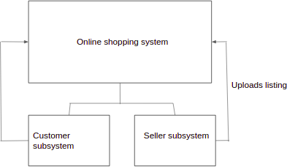

## Product Functions

Enlisted below are all the major functions supported by the online shopping system along with the user classes.

* + - **Register:** for customers and sellers
    - **Login:** for customers and sellers
    - **Logout:** for customers
    - **View Account Details:** for customers and sellers
    - **Edit Account Details:** for customers and sellers
    - **Browse items by category**
    - **Search item:** for customers
    - Filter **Search result** : for customers
    - **View item:** for customers
    - **Add item to cart:** for customers
    - **View shopping cart:** for customers
    - **Change items in cart:** for customers
    - **Proceed to buy:** for customers
    - **Place order:** for customers
    - **Cancel order:** for customers
    - **View orders:** for customers
    - **Rate item:** for customers
    - **Review item:** for customers
    - **View sales:** for sellers
    - **Deliver items:** for sellers
    - **Upload listings:** for sellers
    - **Change language:** for customers and sellers

## User Classes and Characteristics

**Customer** - He/she is a verified user of the system who is intended to buy a product sold by a seller using the platform. The functions used by customer are register, view account, login, browse item, view item, buy item now, add to cart, view cart, proceed to buy, enter delivery address, place order, view orders, write review, cancel order, return item, logout

**Seller** - He/she is a verified user of the product who is intended to sell items over the platform. The product functions used by sellers are register, view account, login, upload listing, your sales, deliver the items to customers.

## Operating Environment

**web applications.**

## Design and Implementation Constraints

For ease of maintenance, the customer will only be able to make payments once items have been added to cart. There is no option to proceed directly to checkout with an empty cart.

## Assumptions and Dependencies

we are assuming that only one customer may place an order at a given time, but will attempt to expand the scope. The recommendation models are assumed to be dependent on the server and its functionalities though relevant to customers will be more clearly defined by the server.

# External Interface Requirements

## User Interfaces

##### -> Home Page:

* + - The home page of this online shopping system is designed to be attractive and user friendly.
    - It includes - search bar, buttons like Sign in, Cart, Returns & Orders

Sell(be be a seller ), Change Language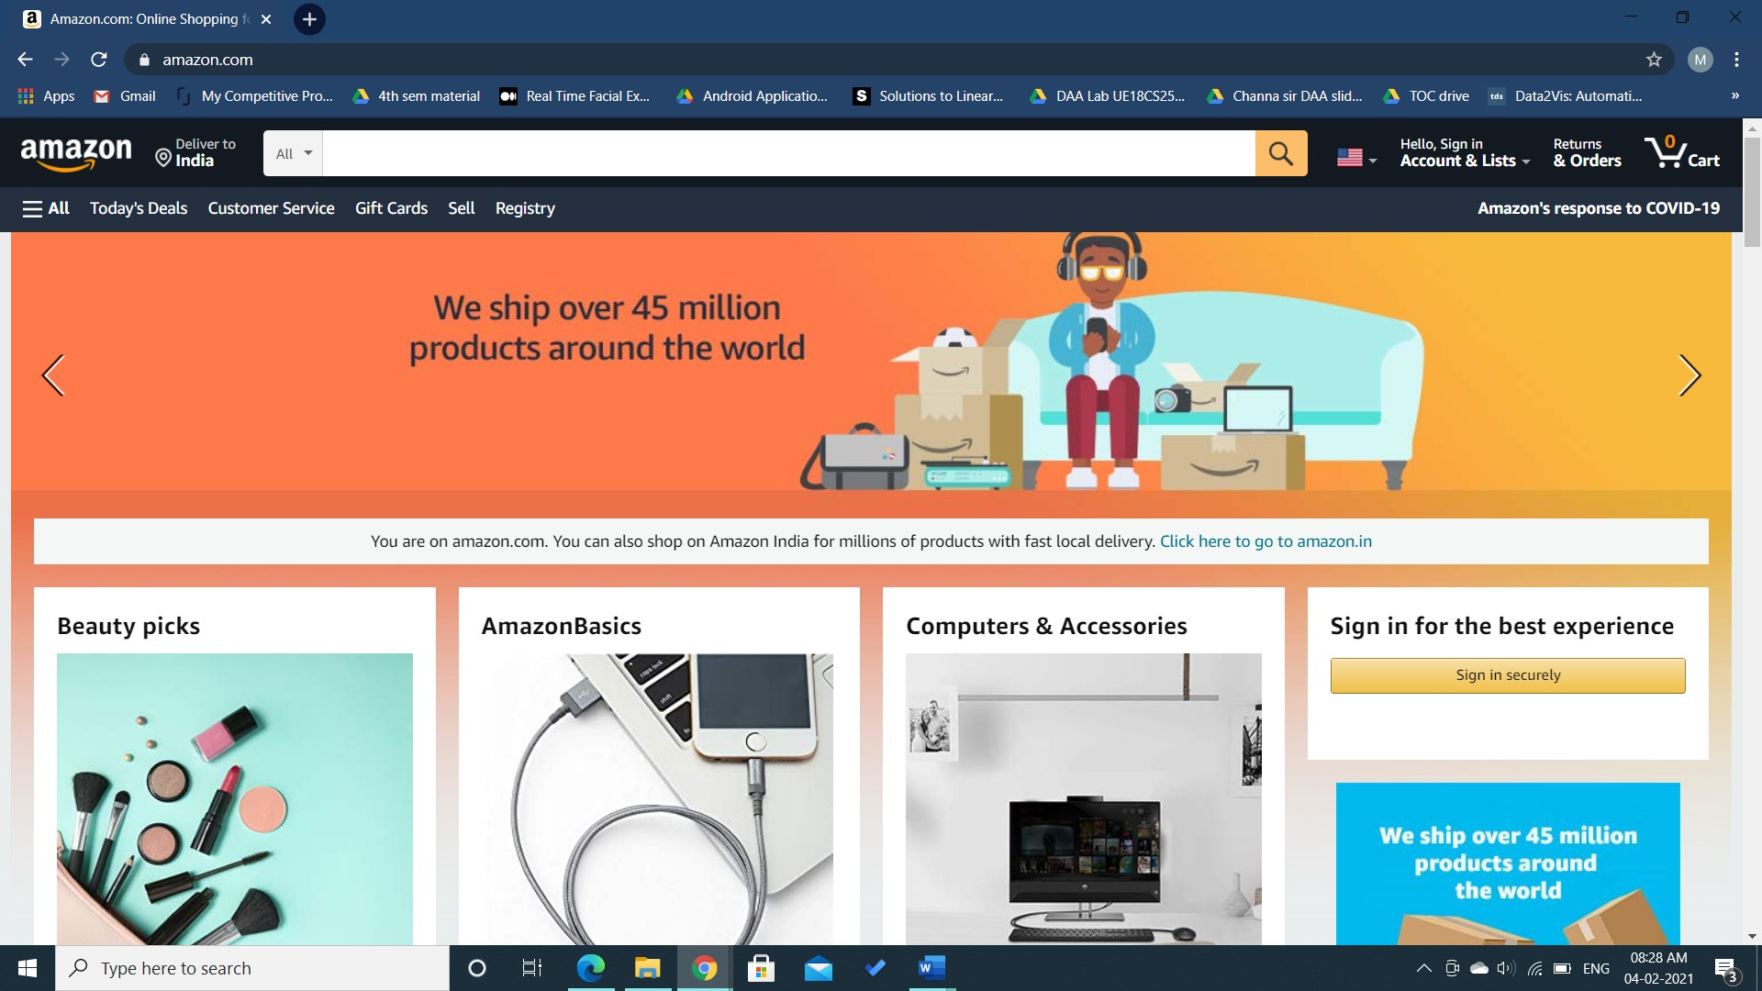 Option, Delivery Address and All Options ans Categories and Browsing History.

Options: ?????????????????

* + - It also displays the top selling products in some of the popular categories like electronics, clothing, skin care etc.

##### -> Sign in:

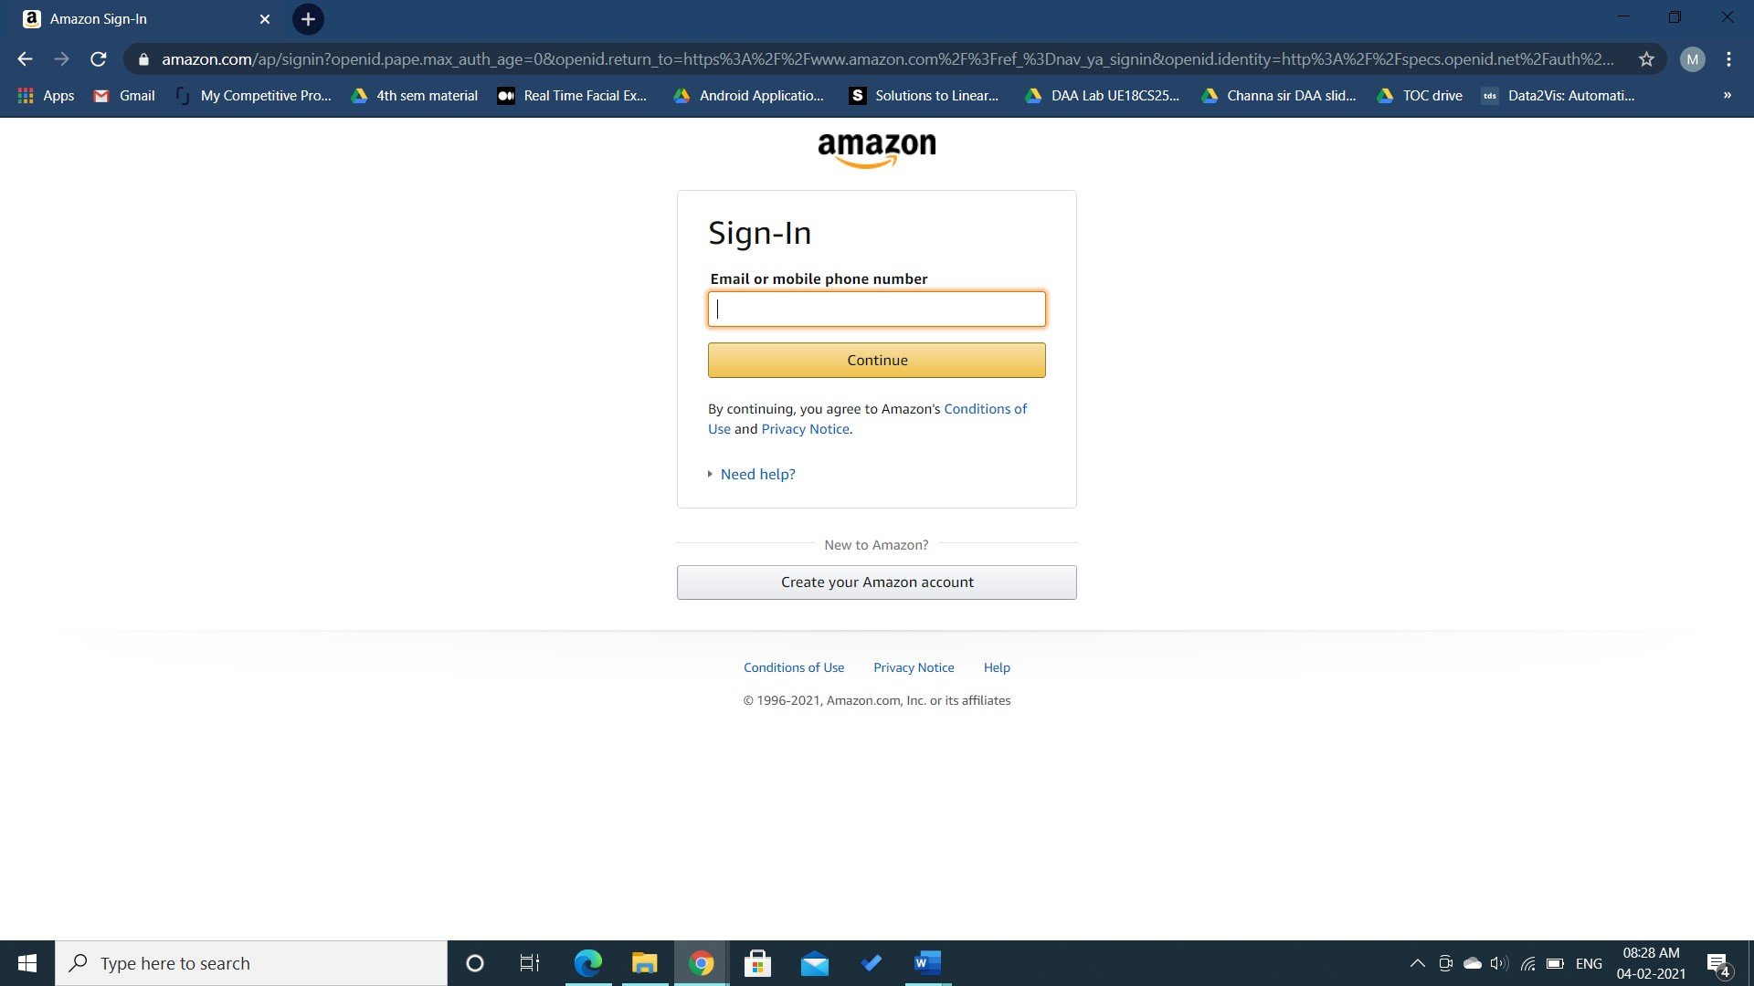

* + - * This page allows the users with an from account under this online shopping system to Sign in to their account. The user can Sign in either with their phone number or email and the password which if entered correctly, takes the user to the homepage of the system and the user name is displayed on the top in the navigation bar.
      * If the entered email id or phone number is wrong, the system displays an error message saying ‘Incorrect email id (or phone number)’ and ‘We can not find an account with that email id (or phone number)’.
      * If the email id or phone number entered by the user is valid and the password entered is invalid, then the system displays an error message saying ‘There was a problem’ and ‘Your password is incorrect’.
      * There is also a ‘Keep me signed in’ checkbox which is optional. If the user checks it, then the system keeps the user signed in.
      * The sign in page also has a ‘Create Your Amazon Account’ button to new users. The user on clicking that button is taken to the Create Account page.
      * There are also some other fields like ‘Forgot Password’, ‘Conditions of Use’, ‘Privacy Notice’, ‘Help’ and ‘Other Issues with sign in’ which takes the user to appropriate pages.

##### -> Create Account:

* + - This page allows users to create a new amazon account. The user is asked to provide their Name, Email id and password. The constraint on the password field is that the password must 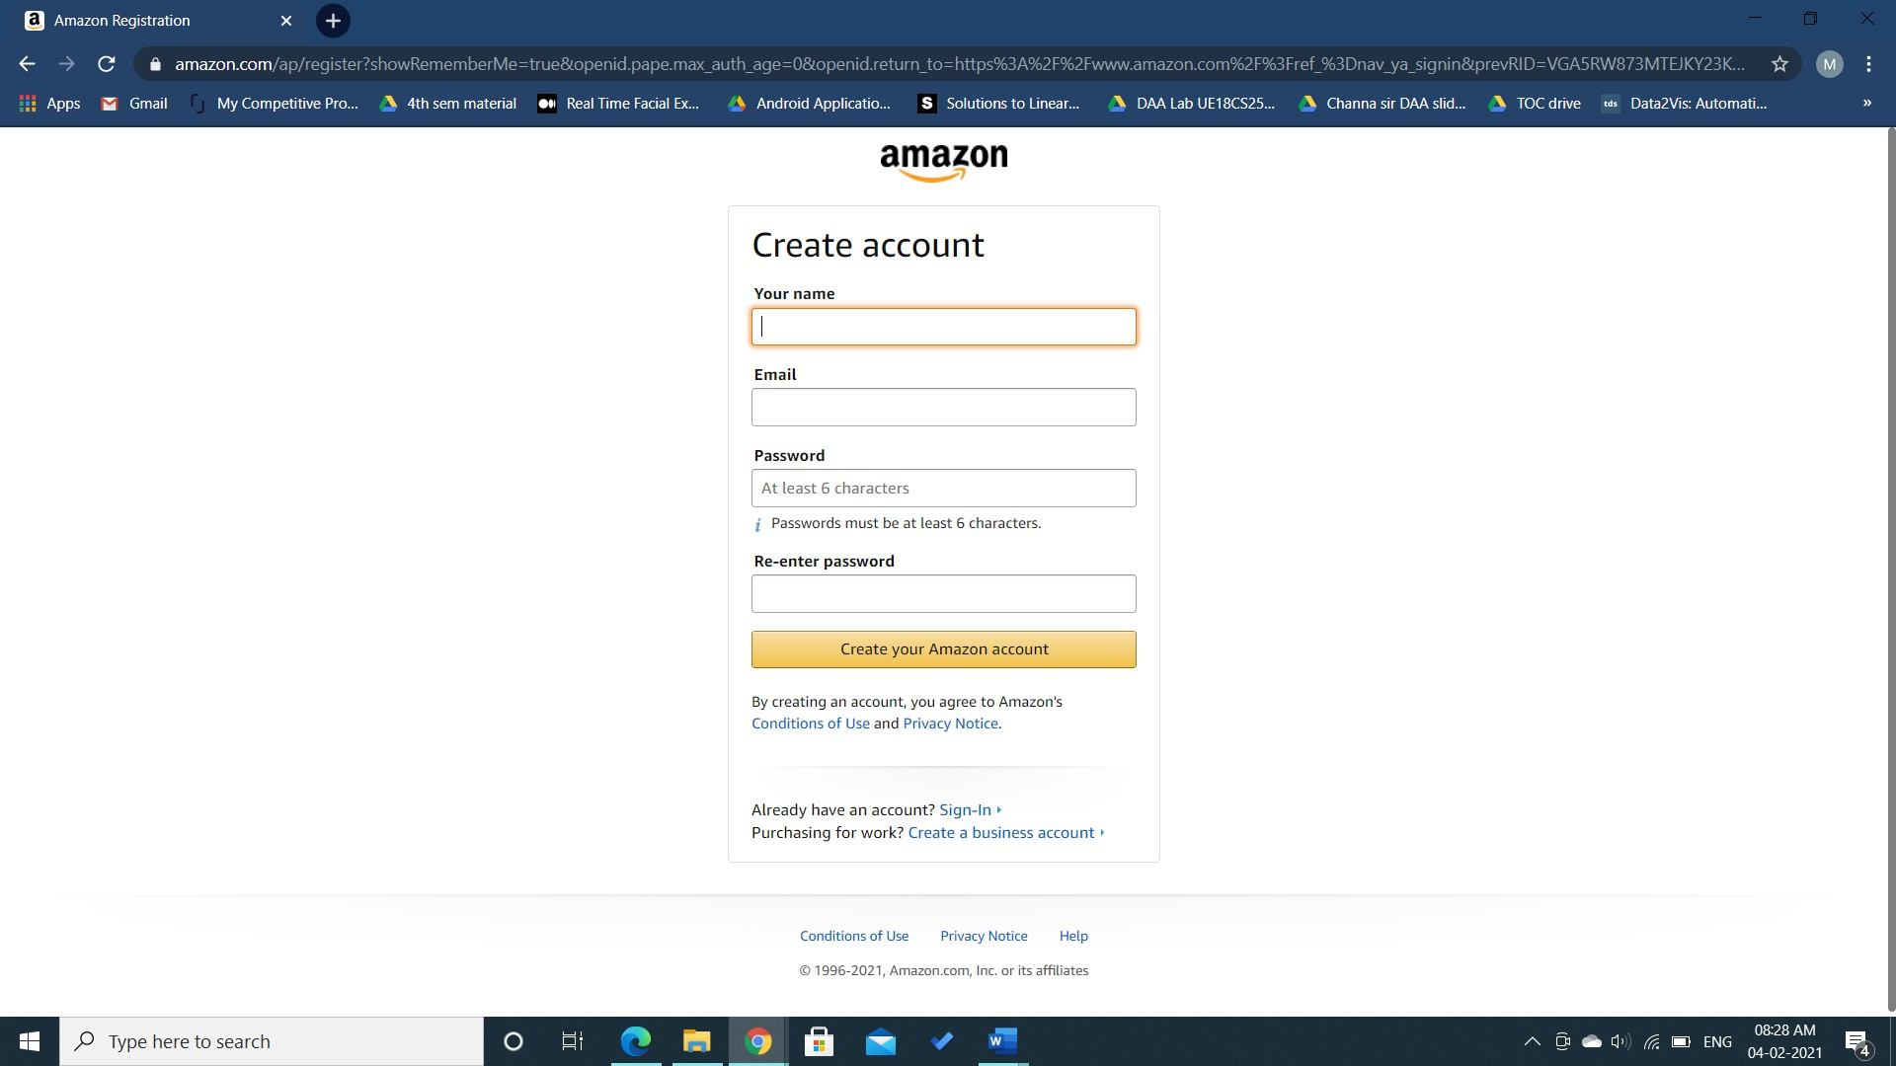contain at least 6 characters.
    - The user is also asked to re-enter the password after which the user can create anew account by clicking on the ‘Create your Amazon Account’ button.
    - There is a sign-in field on this page for the users who already have an account.The user shall be taken to the sign in page after clicking on it.
    - There is also a field for creating a business account if the user is

purchasing products for work. After clicking on the ‘Create a

Business Account’ field, the user will be taken to the business

account creation page. The account creation step is followed by

the steps providing business details and verification process after which the business account creation will be completed.

##### -> Orders:

* + - This page provides the user with the complete information about their orders. It has multiple fields which are ‘Your Orders’, ‘Open Orders’, ‘Buy Again’, ‘Digital Orders’, ‘Cancelled Orders’.
    - Your Orders page gives information about all the orders placed by the user. It gives the user various options like ‘Buy it again’, ‘View your item’, ‘Leave seller feedback’, ‘Write product review’ which provide appropriate functionalities.

* + - The ‘Open Orders’ field provides the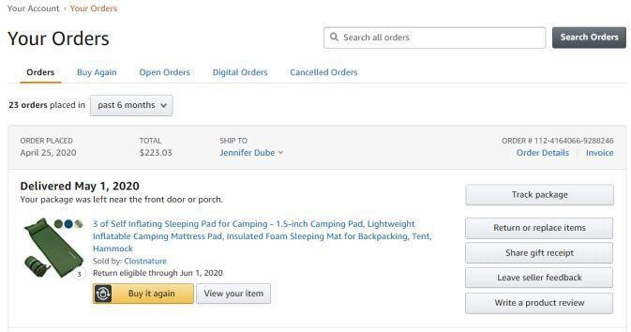 user with the complete information about the orders that the user has placed and hasn't been shipped yet.
    - The ‘Buy Again’ field allows the user to buy their ordered items again.
    - The ‘Cancelled orders’ field provides the user with information about all the orders cancelled by the user.
    - The ‘Digital Orders’ field provides the user with the information about all the digital purchases or orders made by the user.

##### -> Cart:

* + - This page allows the user to save the items they wish to buy in the cart. It provides information about all the items added to the cart by the user. For each item in the cart functionalities like ‘Delete’, ‘Save for later’ and ‘Compare with similar it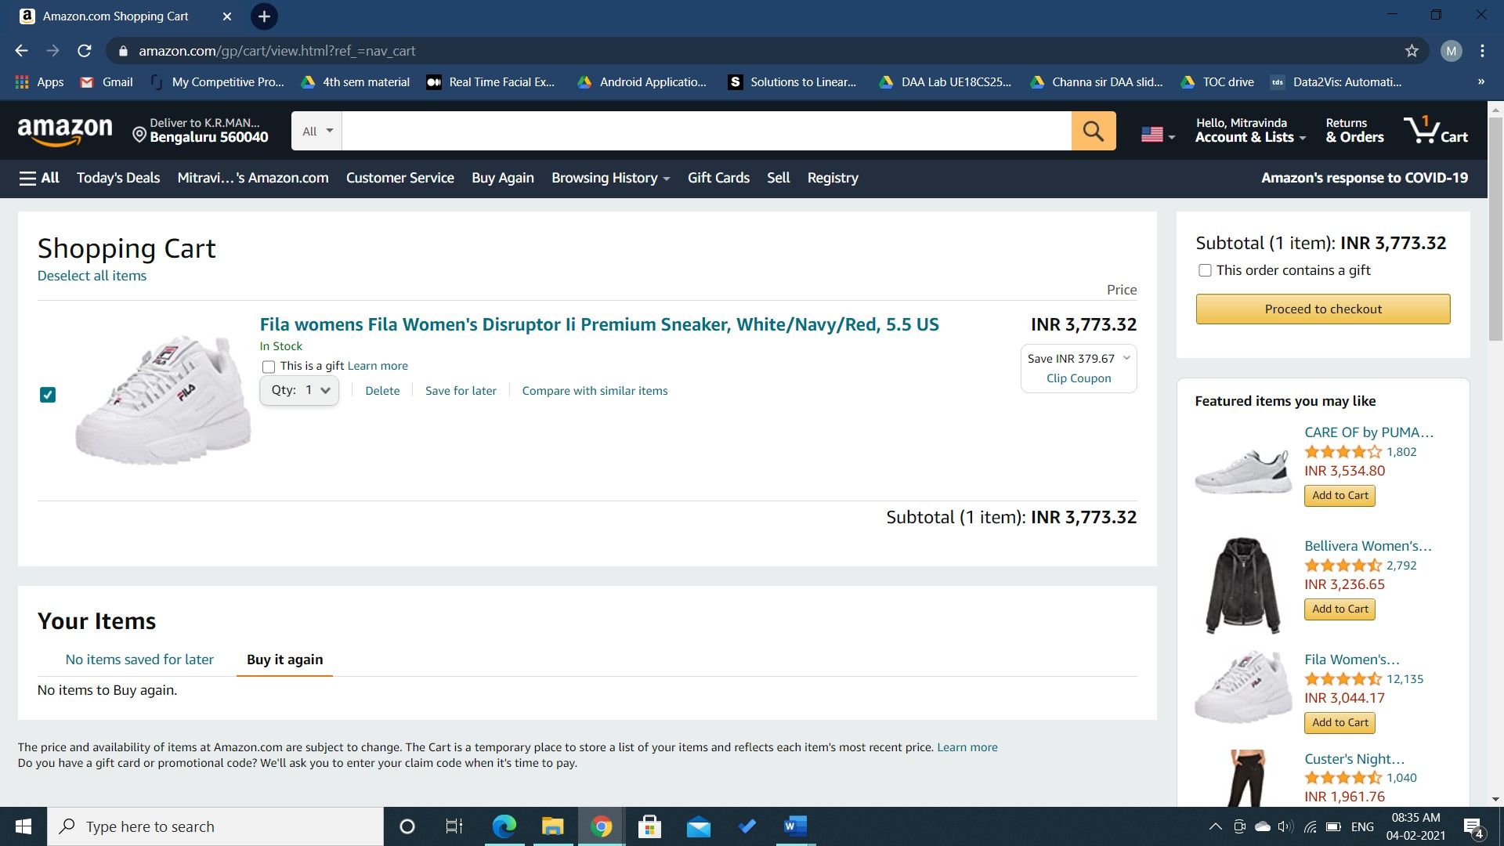ems’ are provided to the user.

##### -> Sell:

* + - This page allows the users to sell their products on this online shopping system. The user wishing to sell their products must sign up as a seller. This requires the user to provide certain details about themselves and their business such as business location, business type, contact address, identity details, GST number and Bank account information.
    - Once the user has been registered as a seller, the

user has to upload their product listings to the online shopping system. The customers can then choose to buy the seller’s products. The seller must then deliver the products to the customers and receive 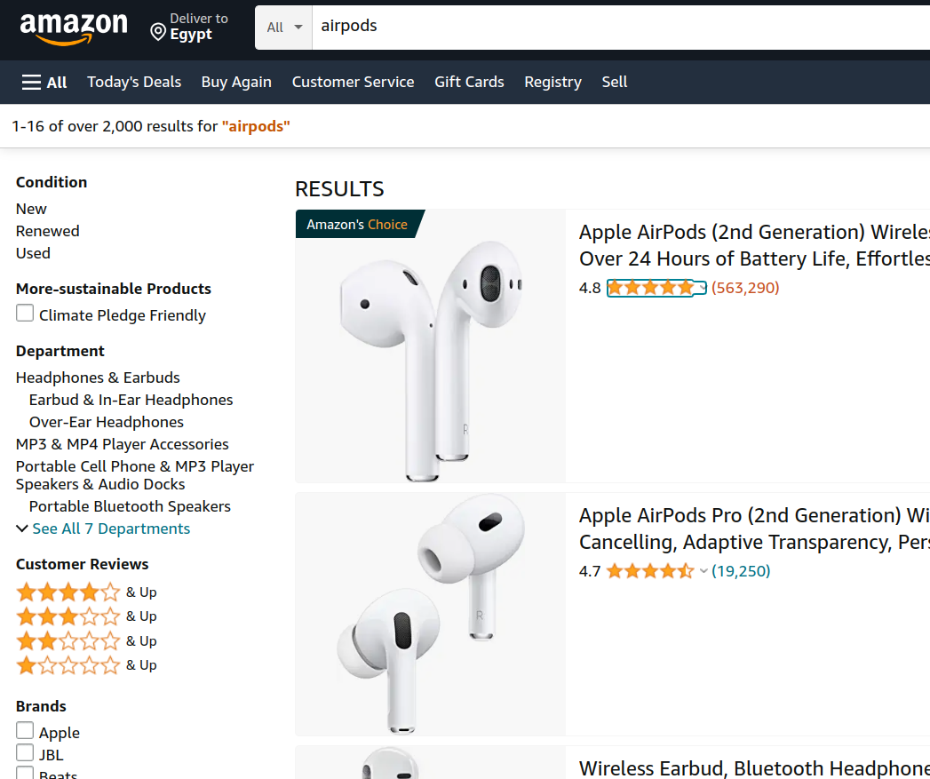payment.

##### -> Search Bar and Search page:

* + - The users can use the Search Bar to conduct a Product Search and find the products they seek quickly and easily.
    - The Search page allow the user to filter search result based on price , rate, brand, ...etc

##### -> Change Language Option:

* + - This allows the user to select the language they 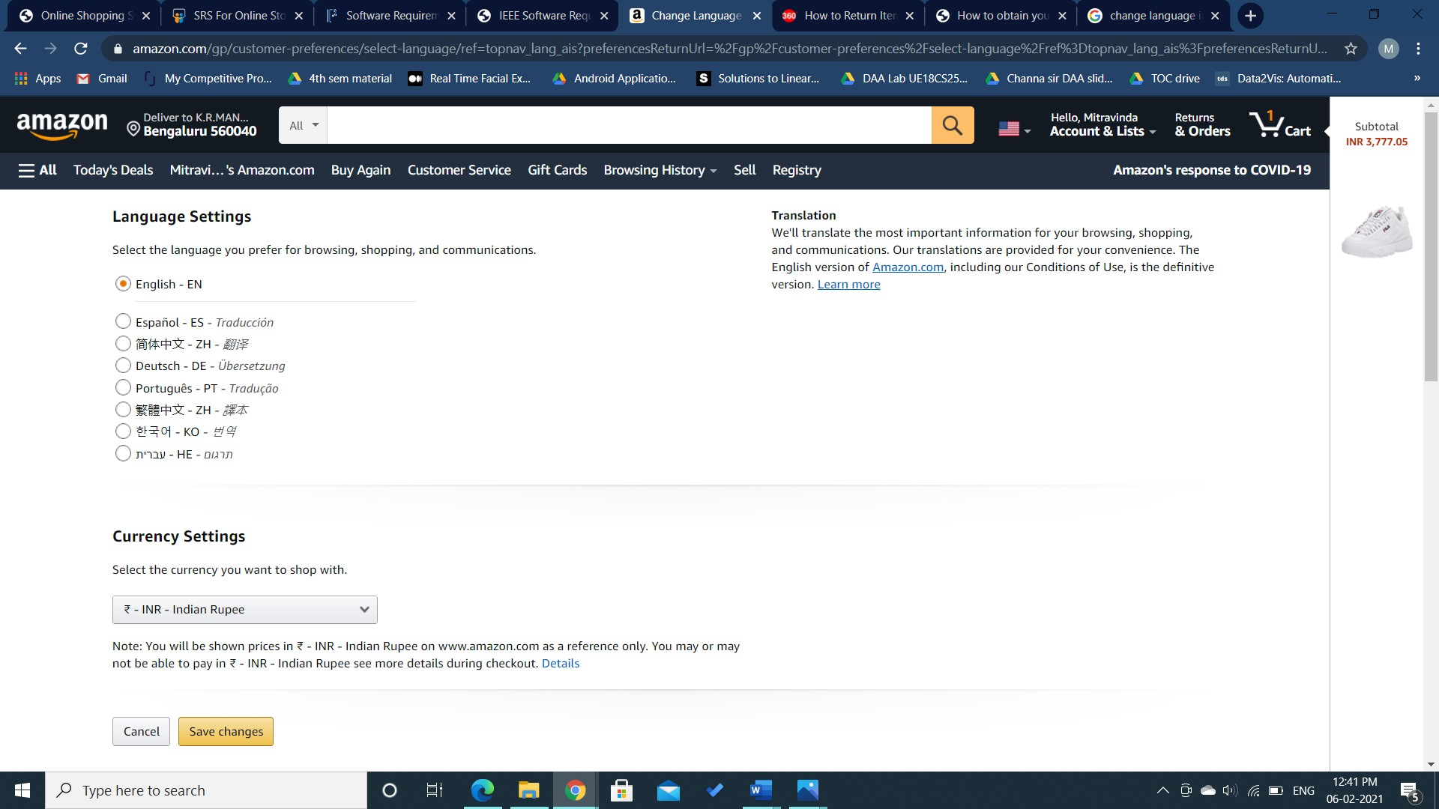prefer for browsing, shopping, and communications.
    - The user can select their preferred language and click on save changes button.

##### -> Delivery Address Field:

* + - This field allows the user to change the location of delivery of the products.
    - The user can also specify a default address for the deliveries.

##### -> User Account on the nave bar:

* + - This field provides the users with various functionalities and account details like ‘Your Orders’, ‘Your payments’, ‘Login and security’... etc.

##### → Categories Field:

* + - This section displays various categories of products from which the user can shop.
    - Here is also provided with various help and settings options for the convenience of the users.

##### -> Product Details Page:

* + - The users while searching for products, can click on them to view the complete information about the products.
    - This usually includes one or more images of the product, product’s name, features, price, brand that is selling it etc.
    - The user after viewing the product details can 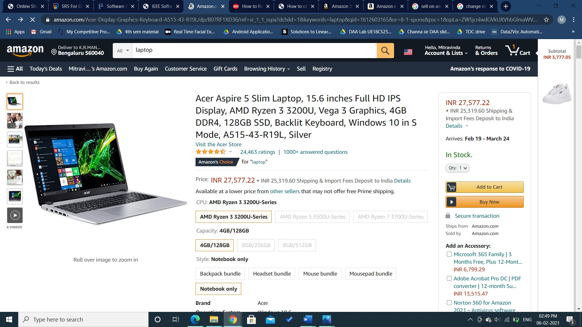then add the product to cart or buy it by clicking on the ‘Add to cart’ or ‘Buy now’ buttons respectively.
    - By clicking on the ‘Buy now’ button, the user will

be asked to select a payment method and click on the ‘Continue’ button to proceed with placing the order.

* + - The user is provided with the billing details of the product. Then, the user can also review the order, edit the delivery address and click on ‘Place your order’ button to complete placing the order.
    - The user will get a message to their email about their order once their order is placed.

# Analysis Models

### CUSTOMER USE CASE DIAGRAM:

* 1. 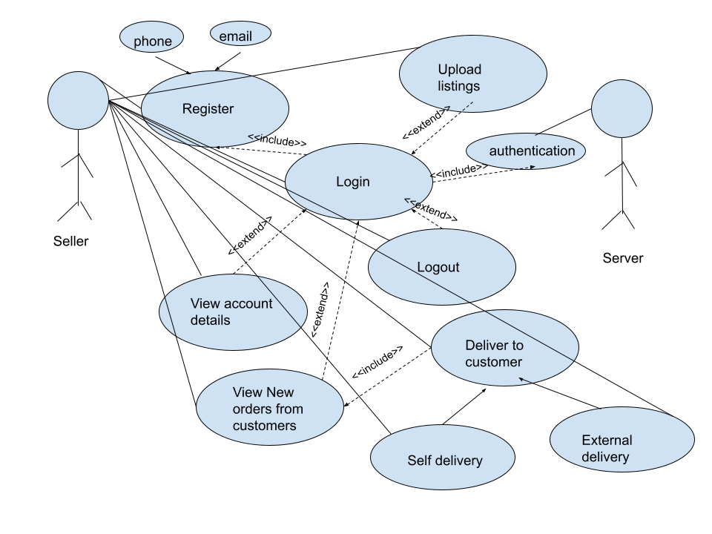**SELLER USE CASE DIAGRAM:**
  2. 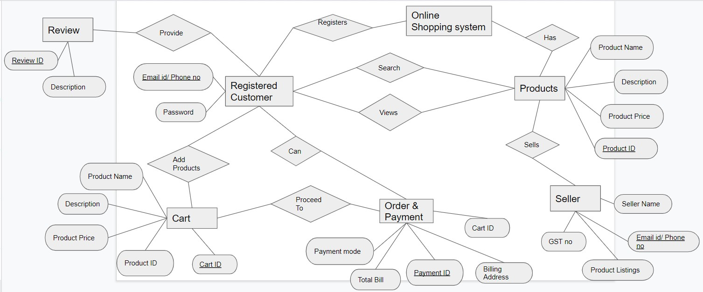**ER DIAGRAM:**

# System Features

## User Accounts

### Description and Priority

Users from both subsystems- customers and sellers must have an account to conduct transactions on the shopping system. Users without system accounts will only have browsing permissions from the home page and do not have options to purchase or list goods on the system. Customers accounts will hold information about their name, email id or phone number, password. Both users can view and login to their accounts and even edit account details in the future. Seller accounts hold information relevant to the selling organization or individual including name, contact, gst number, pan, licenses and address.

**Priority level**: High

### Stimulus/Response Sequences

In the home page, users can select the signup or login button and type in their credentials for registration or for login respectively. Upon matching the required criteria, the account will either get created and the login page is displayed or the user is logged in to his/her account and the home page is displayed. To edit or view account details, the edit or view buttons may be clicked respectively. To edit details, the user may type in the new details and click on save changes. Upon validating the changes, the edited details are successfully updated.

### Functional Requirements

REQ-1: Register

* + - * User: Customers and sellers
      * Input: In sign up page
        + Customer - enters name, email-id/phone number and password
        + Seller - enters name, email-id/phone number, gst no,
      * Output: Successfully registered, the login page is displayed
      * Alternative flow(s):
        + Incase of repeated/invalid email id or phone number, ask user to re-enter a valid choice

REQ-2: View account details

* + - * User: Customers and sellers
      * Input: Click ‘view account details’ button in home page
      * Output: Displays account details that were filled by the user at the time of creating account
      * Alternative flow(s) : none REQ-3: Login
      * User: Customers and sellers
      * Input: In login page
        + Customer - enters registered email-id/phone number and password
        + Seller - enters registered email-id/phone number and password
      * Output: Successfully logged in, the home page is displayed
      * Alternative flow(s):
        + Incase of invalid email id/phone number or a mismatch between user id and password, ask the user to re-enter a valid credential.

REQ-4: Logout

* + - * User: Customers and sellers
      * Input: Click ‘logout’ button in home page
      * Output: User is logged out of the account, Login page will be displayed
      * Alternative flow(s) : none REQ-5: Edit account details
      * User: Customers and sellers
      * Input: In home page
        + Click button to edit account details
        + Select the detail whose value has to be edited
        + Enter the new details
        + Click on save changes
      * Output: Successfully updated
      * Alternative flow(s):
        + Incase of invalid details, ask the user to re-enter a valid credential

## The search facility

### Description and Priority

Customers can search for an item from the large catalogue of items in the shopping system They can search for a product using keywords related to the product. Relevant options are listed in a dropdown of the search bar which upon selection, lists the products related to the keyword searched for

**Priority**: High

### Stimulus/Response Sequences

To search for the product, the customer types in keywords into a search box. This action immediately shows a drop down with the most likely products. The user then clicks on the product he/she wants to view.

### Functional Requirements

REQ-1: Search item

* + - * User: Customers
      * Input: In the home page
        + click on the browse button
        + type in the keywords related to the item like item name/ brand etc.
      * Output: List of products related to the item searched for
      * Alternative flow(s):
        + Displays:

No results for the searched term/keyword

Try checking your spelling or use more general terms

REQ-2: View Item

* + - * User: Customers
      * Input: From the list of items click on an item to view its details
      * Output: Details of the selected item like - price, brand, size, material, quantity, delivery date, images of the item will be displayed, along with the ratings and reviews for that item, and add to cart button
      * Alternative flow(s): none

## The shopping cart facility

### Description and Priority

Once the customer views and selects an item that he/she wishes to purchase, one must add the item to cart using the add to cart button. The shopping cart contains all the items that the customer intends to buy, there is one shopping cart associated with one user account. The user can browse for an item, add it to cart and continue his/her shopping gracefully and purchase all of them at once.

Priority: high

### Stimulus/Response Sequences

To add an item to the shopping cart, the user must click on the add item to cart button in the view item page, and the customer can continue shopping other items. The customer can view all the items in his cart by clicking on the view cart button, upon which a list of all items along with price of individual item, quantity and total cost of the cart is displayed. In this page the customer has the option to remove items from the cart or change the quantity of the products by clicking on the delete item button next to the item or ‘plus’ or ‘minus’ symbols respectively.

From here the customer can proceed to buy all the items in the cart, by clicking on the proceed to buy button or can further continue shopping by going back to the home page by clicking on the continue shopping button.

### Functional Requirements

REQ-1: Add item to cart

* + - * User: Customers
      * Input: In view item page
        + click on the add item to cart button
      * Output: Added item to cart, will remain in the same page
      * Alternative flow(s):
        + Incase of adding an item that is already in the cart, the quantity of that item will be increased by 1 in the cart.

REQ-2: View shopping cart

* + - * User: Customers
      * Input: present in all pages
        + click on the view cart button
      * Output: List of items that were added to cart is displayed along with item details and total cost
      * Alternative flow(s): Incase the cart is empty, ‘cart empty’ is displayed and the customer has the option to return to home page by clicking on continue shopping

REQ-3: Change items in cart

* + - * User: Customers
      * Input: In shopping cart page
        + click on delete item button present next to the item to delete the item from the cart
        + to change the quantity of items click on ‘+’ to increase quantity by 1,

#### or ‘-’ to decrease quantity by 1

* + - * Output: Changes reflected in the shopping cart page based on activity performed, the item will be removed from the page if it is deleted
      * Alternative flow(s): none REQ-4: Proceed to buy
      * User: Customers
      * Input: In shopping cart page
        + click on proceed to buy button
      * Output: Payment page is displayed
      * Alternative flow(s): none REQ-5: Continue shopping
      * User: Customers
      * Input: In shopping cart page
        + click on continue shopping button
      * Output: home page is displayed
      * Alternative flow(s): none

## Payment and Delivery

### Description and Priority

Once the customer proceeds to buy from the cart page, the delivery and payment page is visible where the total cost of all the items in the card is visible and the customer has to fill in the details necessary for delivery to the customer’s desired address.

### Stimulus/Response Sequences

To buy the items in the cart, the customer has to click on proceed to buy button in the shopping cart page, then the ‘delivery and payment’ page is displayed where the customer has to fill in the delivery address- house number, street address, pincode, city, state and click on delivery to this address. On success an order will be placed.

### Functional Requirements

REQ-1: Delivery details

* + - * User: Customers
      * Input: In delivery & payment page
        + Enter the delivery address:

house number, street address, pincode, city, state

* + - * + Click on deliver to this address
      * Output: the payment page is displayed
      * Alternative flow(s): Incase of invalid address entry, an error message is shown to the user

REQ-3: Place order

* + - * User: Customers
      * Input: In place order page
        + Click on place order
      * Output: Order successfully placed, the home page is displayed
      * Alternative flow(s): In case the user exists the page, order is not placed

## Orders

### Description and Priority

The customer can view and manage orders that are yet to be delivered to the customer. He/she can cancel the order that is yet to be delivered , or view past orders. Also upon successful placing of the order, the customer can track order, i.e the delivery stage, shipment of the item along with the location- city, state in which the item is currently in.

Priority: Medium

### Stimulus/Response Sequences

In the home page the customer can click on ‘orders ’ button, a list of past and existing orders are displayed. If the customer wants to cancel an existing order that is not yet delivered he/she can click on cancel order in the orders section of the orders page. If the customer wants to track the order that had been placed earlier and yet to be delivered he/ she can click on the track order button of that particular item and the different stages of the delivery of the item will be displayed along with the date, time and location at that time, and current stage of the item.

### Functional Requirements

REQ-1: View orders

* + - * User: Customers
      * Input: In home page
        + Click on orders button
      * Output: the past and existing orders are displayed
      * Alternative flow(s): none REQ-2: Cancel order
      * User: Customers
      * Input: In orders and returns page
        + Click on cancel order button present next to the order and type in the reason for cancelling
      * Output: the order is successfully cancelled, the orders and returns page remains displayed
      * Alternative flow(s): none REQ-2: Track order
      * User: Customers
      * Input: In orders page
        + Click on track order button present next to the order
      * Output: the tracking information of that order is displayed
      * Alternative flow(s): none

## Other system features

* + 1. **Rate and Review:** The rate and review features are available to the client subsystem and are used to build a community of consumers. Each customer has the option to review purchased products and assign ratings or satisfaction levels. The system may choose to terminate products that have low satisfaction ratings.

## **Seller Sub System**

### Description and Priority

Sellers can sell their items using the features provided by the system such as easy uploading of the list of items to sell and effective notification system when the order is made by a customer and display history of the sales made in the past

Priority: High

### Stimulus/Response Sequences

To upload the listings of the items that the seller wishes to sell, he/she has to click on the upload listing button and enter the details for each item such as name of the product, price, colour, material, quantity, brand. For viewing the current order from the customers he/she has to click on the view of new orders, where the details of the customer like the delivery address and the items booked are visible. To deliver the ordered items to the customers one can click a self delivery option where he/she can deliver to the customer independently, or can click use external delivery and can hire an external delivery system to perform the delivery.

### Functional Requirements

REQ-1: Upload listing

* + - * User: Sellers
      * Input: In home page
        + Click on upload listings and enter details (name of the item, price, material, quantity, colour) of all the items to sell
      * Output: the items successfully uploaded, customers can view these items
      * Alternative flow(s): none REQ-2: View new orders
      * User: Sellers
      * Input: In home page
        + Click on view new orders
      * Output: displays the orders for his/her items from the customers
      * Alternative flow(s): none REQ-3: Deliver to customer
      * User: Sellers
      * Input: In view new orders page
        + Click on deliver to customer and select either

deliver independently (self delivery)

external delivery (hire external delivery agency)

* + - * Output: Item added to delivery, items undergo delivery process
      * Alternative flow(s): none

6. Other Nonfunctional Requirments

## 6.1 Security Requirements

To ensure secure transfer of data, the system must use secure sockets in all transactions that include any confidential customer information. The system may choose to automatically log out all customers after a period of inactivity and verify by confirmation all the transactions with the customer’s web browser. The system will ensure that cookies and all temporary storage do not

hold any sensitive information. The customer’s web browser must never display a customer’s password or credit card details. The system’s back-end servers must never display a customer’s password and these servers must only be accessible to authenticated administrators. These databases must be encrypted and within the company's perimeter.

The service can ensure user identity authentication using two-step verification procedures. Further, the system can ensure that any additional security risks experienced by the users can be reported to the system immediately.

# Appendix A: Glossary

Some key terms used repeatedly throughout the document are

1. **Customer subsystem**: A subsystem within the online shopping system support for customers
2. **Seller subsystem:** A subsystem within the online shopping system support for sellers
3. **GST**: Goods and services tax applicable to all products
4. **PAN:** permanent account number
5. **Seller listing:** Sellers will add their product listings to the system
6. **Turnover:** net sales generated by the system
7. **avg response time:** average time taken to respond to a user request
8. **failure rate:** frequency of failure of an individual component
9. **liability failure rate:** amount of product or service defects that hold the system liable
10. **inventory turnover:** ratio that measures the number of times **inventory** is sold or consumed in a given time period
11. **acquisition cost:** Customer Acquisition Cost is the cost of winning a customer to purchase a product/service
12. **brand awareness:** marketing term that describes the degree of consumer

**recognition** of a product by its name

#### **fulfilment cost: costs** associated with receiving and storing products along with processing orders from handling to shipping.

1. **market share growth:** growth strategies to broaden market share